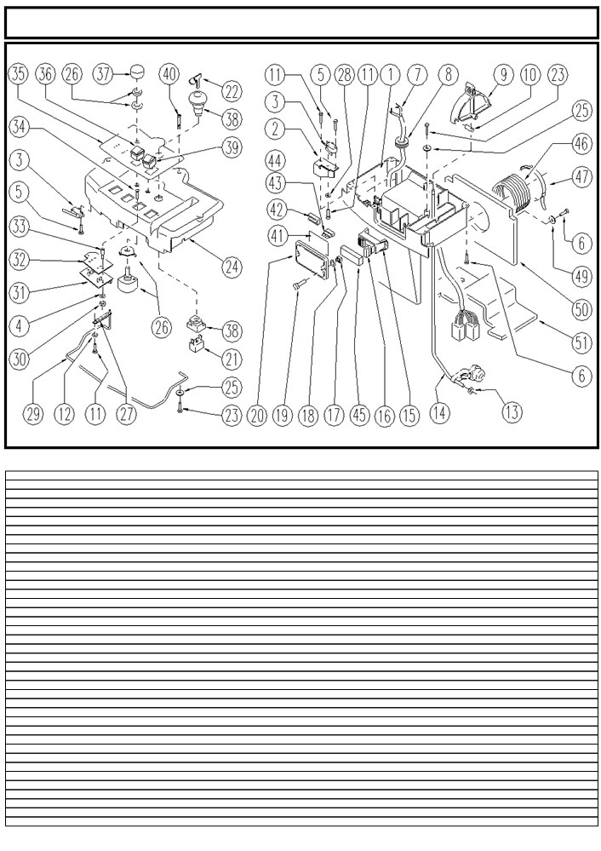
Control Panel New Version

 | ITEM | SKU | DESCRIPTION | QTY |  | ITEM | SKU | DESCRIPTION | QTY
 |  | E86318 | Control Panel ASM |  |  | 26 | E89153 | Potentiometer | 1
 | 1 | E87905 | Lower control panel | 1 |  | 27 | E86774 | Spring FS28/32 | 1
 | 2 | E87904 | Spring | 1 |  | 28 | E86797 | Washer | 1
 | 3 | E89087 | Microswitch | 3 |  | 29 | E89216 | Lever | 1
 | 4 | E88220 | Washer | 2 |  | 30 | E88225 | Nut | 2
 | 5 | E89154 | Screw | 6 |  | 31 | E89524 | Brush Delay Board | 1
 | 6 | SL04187 | SCREW | 4 |  | 32 | E87927 | Plate | 1
 | 7 | SL23741 | WIRING | 1 |  | 33 | SL07534 | SPACER | 2
 | 8 | SL23695 | FAIRLEAD | 1 |  | 34 | SL04384 | SCREW | 2
 | 9 | E86519 | Lever | 1 |  | 35 | E89110 | Decal | 1
 | 10 | E89474 | Solution Rod ADJ | 1 |  | 36 | E87805 | Switch FS28 | 1
 | 11 | E88219 | Screw | 2 |  | 37 | E86644 | Knob | 1
 | 12 | E88229 | Washer | 1 |  | 38 | E86988 | Main Switch | 1
 | 13 | E87868 | Self Locking Nut | 1 |  | 39 | E87681 | Momentary Switch | 1
 | 14 | E87867 | Solution Control Rod | 1 |  | 40 | E86367 | clip | 1
 | 15 | E89468 | Fuse Carrier | 1 |  | 41 | SL25994 | LABEL | 1
 | 16 | E86825 | Fuse 5 amp | 4 |  | 42 | SL23209 | FUSE TWEEZERS | 1
 | 17 | E87830 | Nut | 2 |  | 43 | E89086 | Fuse 10A | 1
 | 18 | E87876 | Gasket | 4 |  | 44 | E86647 | Fuse 40A | 1
 | 19 | E87877 | Screw | 2 |  | 45 | SL23893-2 | COVER | 1
 | 20 | E86543 | Fuse Cover | 1 |  | 46 | E88420 | Hose, Exhaust Vent | 1
 | 21 | E86988 | Main Switch | 1 |  | 47 | FSVR00083 | CLAMP | 1
 | 22 | E86988 | Main Switch | 1 |  | 49 | E86577 | washer | 2
 | 23 | SL04240 | SCREW | 2 |  | 50 | ITSO00031 | SOUND-PROOFING
 | 24 | E86997 | Upper Control Panel | 1 |  | 51 | ITSO00032 | SOUND-PROOFING
 | 25 | E86448 | Washer | 2

0001 MPVR03843 PANEL COMANDI INFER. 1,00 --
0002 LAFN05615 SPRING LEVA ANTISCH./SUPP. MICRO 1,00 03/2004 --
0003 MEC 00310 MICROSWITCH 3,00 03/2004 --
0004 VTRS00268 WASHER D.3 2,00 03/2004 --
0005 VTVT00744 SCREW 6,00 03/2004 --
0006 VTVT28553 SCREW TCB-TC 3.5X16 6,00 03/2004 --
0007 MECB00773 CABLE PANNELLO COMANDI 1,00 --
0008 MEVR01331 FAIR-LEAD PVC 1,00 03/2004 --
0009 MPVR03845 LEVER REGOLAZ. 1,00 03/2004 --
0010 LAFN05103 ARTICULATION SUPERIORE 1,00 03/2004 --
0011 VTVT00820 SCREW TC+ M.3,5-10 5,00 03/2004 --
0012 VTRS15958 WASHER D. 5 X15 UNI 6593 1,00 03/2004 --
0013 VTDD00157 NUT M. 6 DIN 985 ZN 1,00 --
0014 LAFN05645 ROD SUPERIORE RUBINETTO 1,00 --
0015 MEVR01387 BODY SENZA TERMINALI 1,00 03/2004 --
0016 MEVR01132 FUSE A LAMA 5 A. 4,00 03/2004 --
0017 VTDD00167 NUT M.6 2,00 03/2004 --
0018 GUGO00150 NUT 4,00 03/2004 --
0019 VTVT00858 SCREW 2,00 03/2004 --
0020 MPVR35628 COVER LAV. 1,00 03/2004 --
0021 MEC 00403 CONTACT - 1,00 --
0022 CHVR00051 DIASASS.SPANNERPULSANTE FUNGO 1,00 --
0023 VTVT07859 SCREW TCB-TC 3.5X13 UNI6954 2,00 --
0024 MPVR03841 PANEL COMANDI SUPER. 1,00 --
0025 VTRS13750 WASHER D. 5X14 INX 2,00 --
0026 MEVR01432 POTENTIOMETER A FILO 1,00 03/2004 --
0027 MLML00196 SPRING PER GIUNTO HS NADIR 1,00 03/2004 --
0028 VTRS00501 WASHER D. 4 0.232 UNI 6592 1,00 03/2004 --
0029 LAFN05584 LEVER TRAZIONE 1,00 03/2004 --
0030 VTDD21115 NUT M 3 INOX 2,00 03/2004 --
0031 MECE00346 BOARD LED 1,00 --
0032 MPVR02781 PLATE LED 1,00 03/2004 --
0033 LAFN04047 SPACER X SCHEDE M3 15x8x8 2,00 03/2004 --
0034 VTVT00865 SCREW TSP-TC M 3X 6 UNI7688 INX 2,00 03/2004 --
0035 ETET01263 LABEL PANN.COMANDI 1,00 03/2004 --
0036 MECI46638 COMMUTAT.SWITCH0.CT. 0401/C2 1,00 03/2004 --
0037 MPVR36404 KNOB SPECTROL 635M.NE 1,00 03/2004 --
0038 MEC 00323 BUTTON FUNGO 1,00 --
0039 MEC 00309 SWITCH 1,00 03/2004 --

